Power Management System
SolarQuest® has developed a Power Management System that offers an integral view of the electric power (currently and historically consumed) where it is installed. By strategically placing sensors on the equipment and auxiliary outputs, the Power Management System records electrical power consumption, every minute. If the strategic sensor nodes are expanded to include more measuring points, this will create a more detailed power consumption chart.
One of the major advantages of the Power Management System by SolarQuest® is the availability on the Internet of all the information collected. SolarQuest® hosts the private database for all the data collected and processed. Then, the authorized database owners may request any portion of their data, using a web browser. This means that data is accessible world-wide via the Internet to authorized users. Furthermore, we permit user control over the scaling factors of the sensors placed in the field. This will diminish the level of specialization for the technician in charge of installing the data acquisition equipment in the field, simplifying installation of the system. The scaling factors are defined by filling out a web form and uploading it to the database.
The data measured every minute is averaged in periods of 15 minutes. The time-stamped 15 minutes intervals are displayed on the Internet either in a table form, or as a graph.
To customize the time interval over which the user is interested in requesting data, we offer the Graph Builder. This form allows the user to obtain a graph of the selected variables within the time frame specified.
We have installed an experimental Power Management System in our facilities at Santa Cruz, California. Our Power Management System has been customized to match our solar powered, grid-backup energy system, and we have also included climate measurements. This information advises us of how much electric power our solar panels produce, how much we take from the grid, how much our AC loads consume, how much our DC loads consume, when, and how often. Please check out the energy performance of our solar system in our Server Room, where all SolarQuest® servers are installed, including the one that hosts our Power Management System database and web interface:
http://data.solarquest.com/
The next images show the most relevant information available on the Internet, for the Power Management System installed at our facilities.

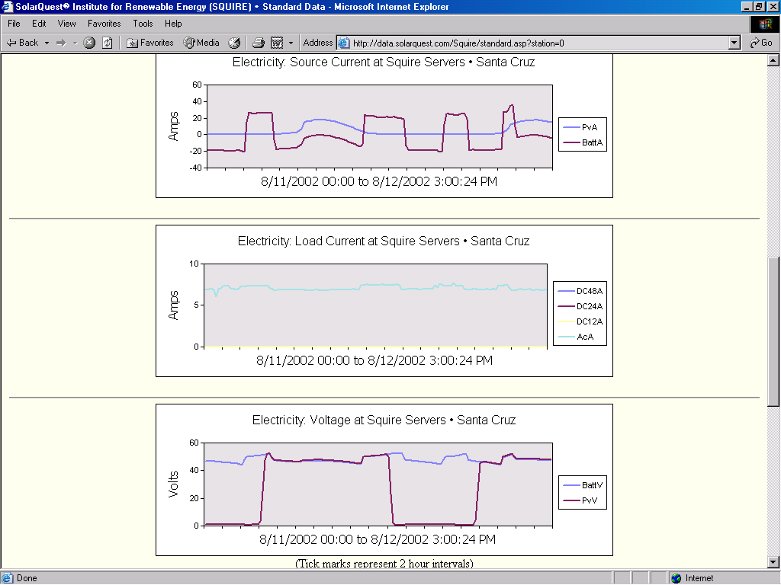
Electricity graphs Display

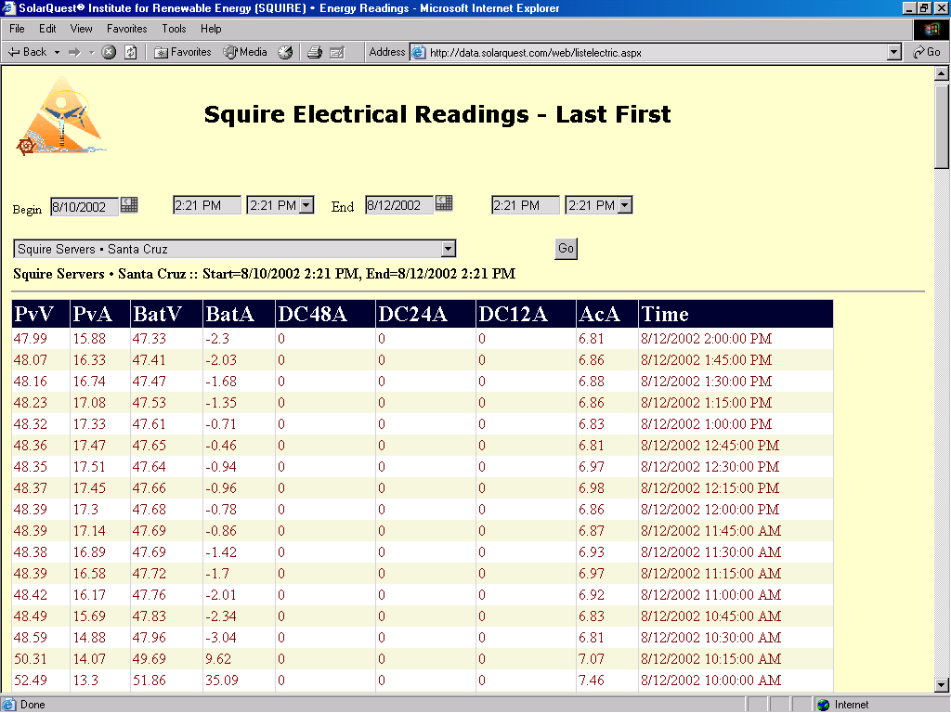
Tabular display

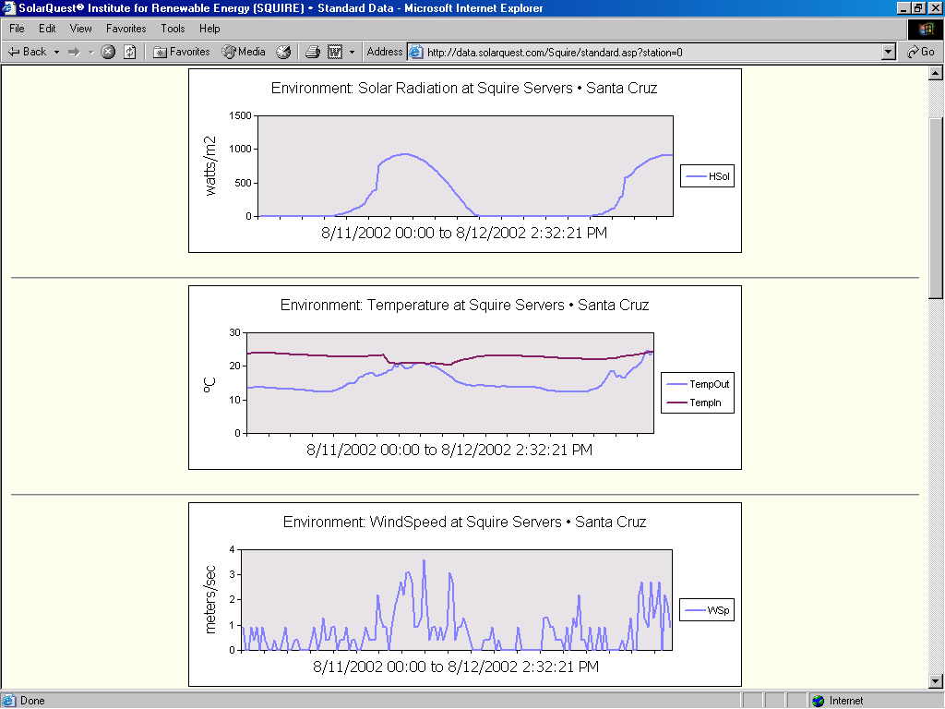
Environment graphs

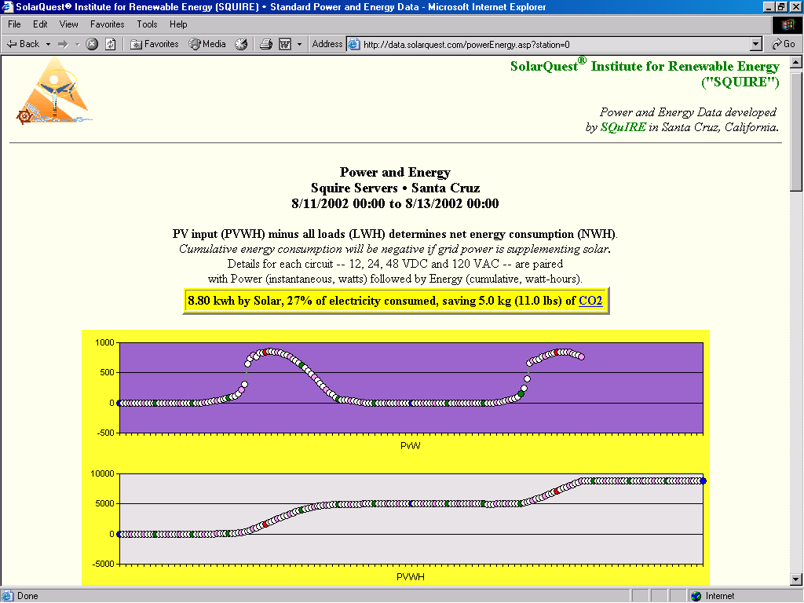
Energy graphs

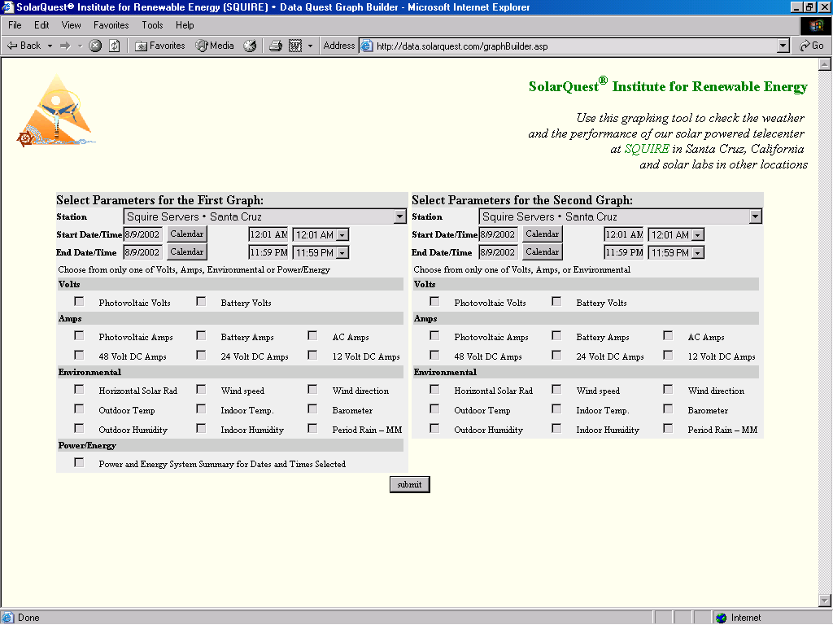
Graph Builder for authorized users

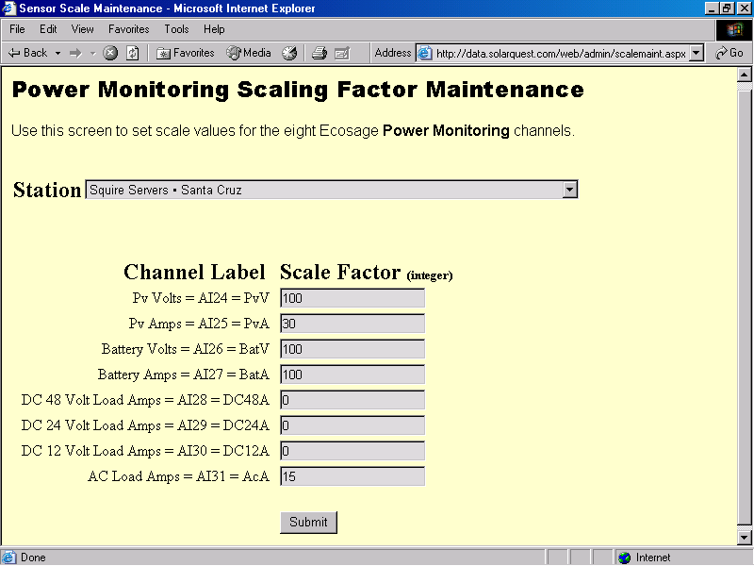
Field technician screen to configure sensors scales (password protected)
The following schematic shows the Photovoltaic system and Power Management System installed in SolarQuest® at Santa Cruz, California.
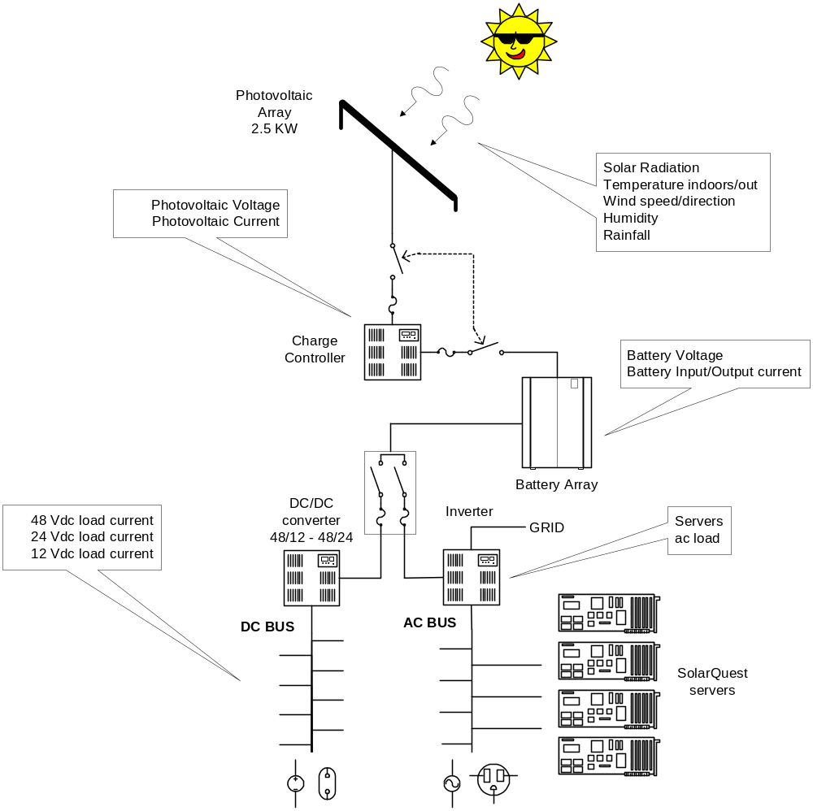

The environmental parameters we are measuring are: solar radiation, indoor and outdoor temperature, wind speed and direction, humidity and rainfall.
In the next page, there is a more detailed schematic of the instrumentation deployed to record electrical and climate measurements, and its data flow.

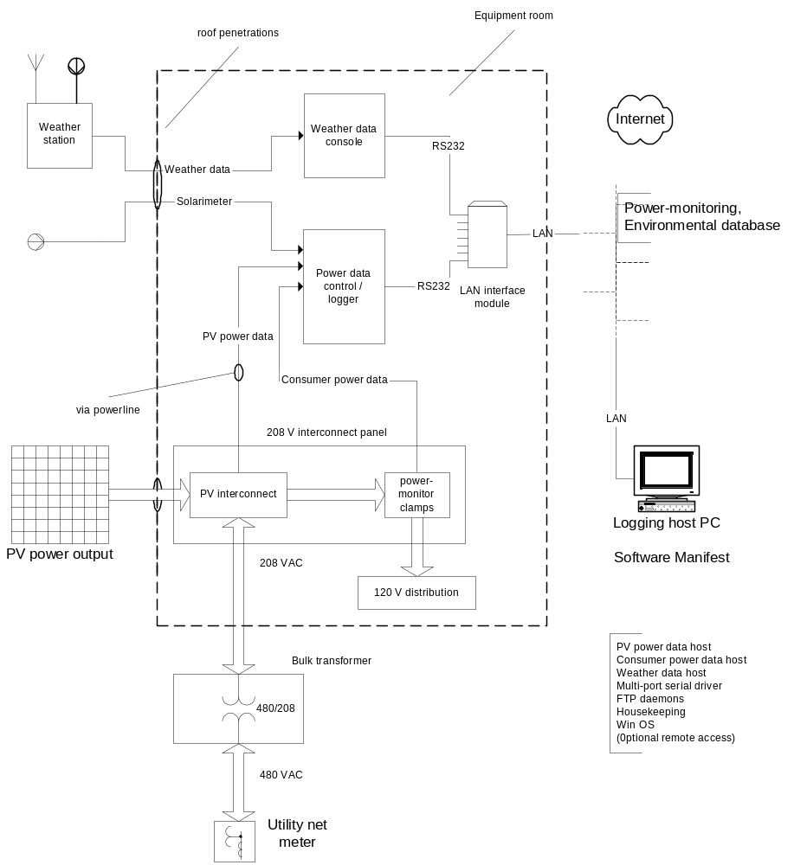

Instrumentation Overview

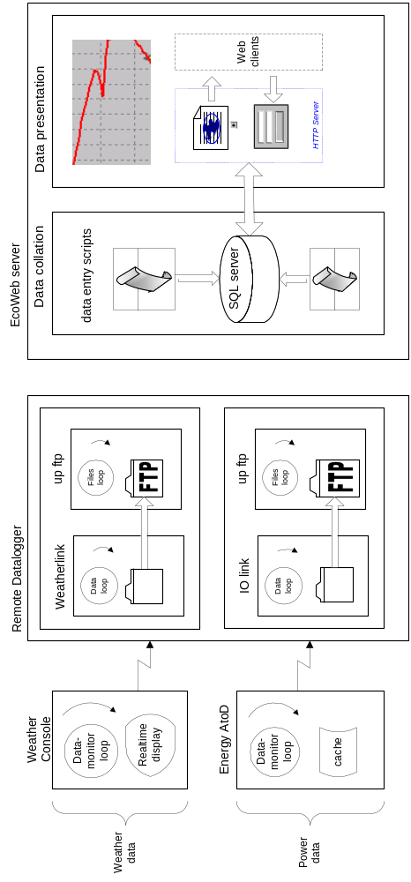
Data Flow Overview

Instrumentation System
Representative Illustrations

Power monitor data logger:
Control Plus module, including 6 available analog input channels. (Shown is the smaller Control module.)
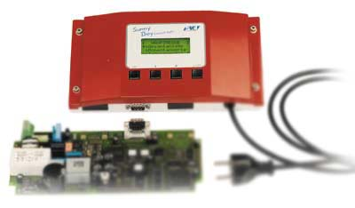

Power monitor transducer clamp sets: 4-20mA :: 0 – 108.2 kW
1 set per sub-meter, maximum 4 for logger module (above). Each set is wired and clamped onto the 3 phases of the consumer branch circuit, within the panel. (Installation requires electrical power off and lock-out.) Control wiring is 24VDC, twisted pair (non-conduit).


Serial port -LAN interface adapter: puts RS232/485 equipment onto the LAN. Requires virtual port software driver installation on supervisory PC. Shown: 8-port; recommended: 1 - 2 ports.
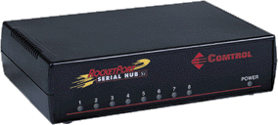 | 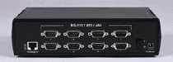

Solarimeter, with tilt bracket, for rooftop solar-panel plane mounting.
Recommended for input channels 1-2; range: 0 - 1500 Watts/m²

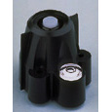
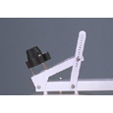

Weather station: equipment-room, and rooftop temperatures, plus wind, rain, barometric pressure. (Also shown with optional solar radiation and UV sensors, recommended for site assessment-only installations.)

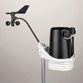
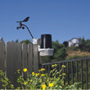

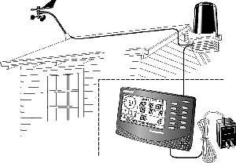

Wall-mount industrial computer: for installation in customer equipment room. Optionally replaces both LAN adapter, above, and customer-supplied computer system. If required, specify extended temperature range operation.

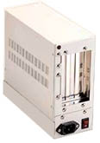
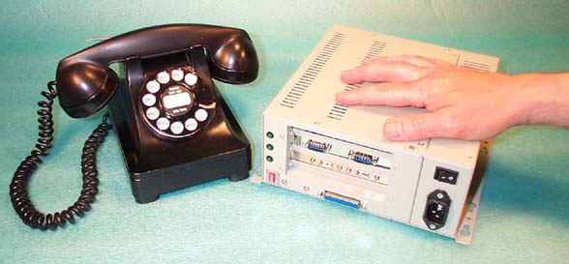

Configurable Solar-Powered Energy System



